The Balkan Three Countries Trek
11-18th September 2021
Accommodation

The accommodation is in simple homestay/guest house/lodge- style with simple bathroom facilities. Rooms are likely to accommodate between two to five people per room and it may be necessary for male and female groups to share the room, but not guaranteed in each guesthouse. It always depends on availability of rooms.
Sheets and blankets, towels, shampoo, warm water and other basic services are provided, but it’s recommended to pack a travel towel and sleep liner just in case.
Private rooms at additional cost; limited availability.

Polia Guest House - Theth
Polia guest house is located in the center of the village of Theth and it is one of the first guest houses opened in this region. The owner has protected the original building of his family and has invested to make the place nice and cozy for his guests. The rooms of this beautiful and traditional stone house are located to the first and second floors and offer amazing views to all sides of the valley.
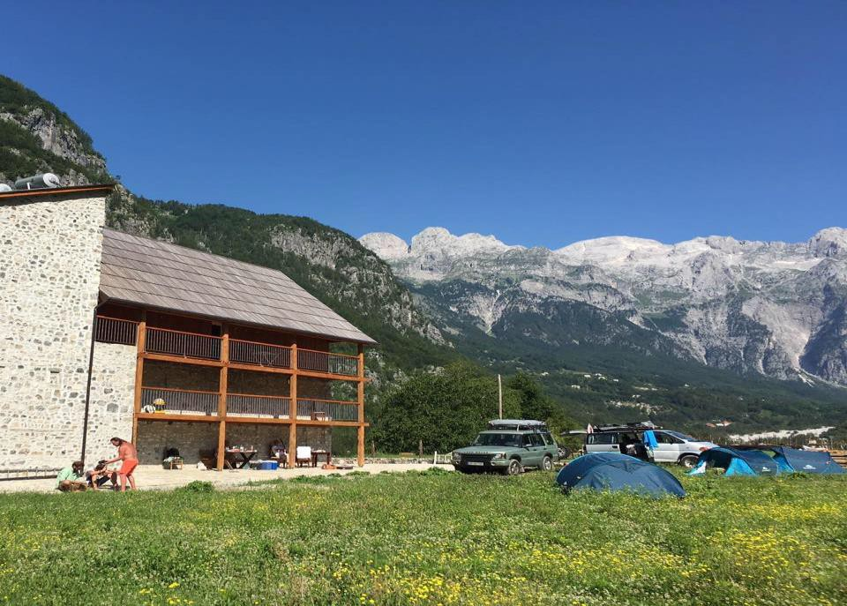

More about Polia Guest House

Kol Gjoni Guest House - Valbona
It is a family-run traditional wooden roof alpine guest house. The rooms are nice, clean and comfortable, the food is all home cooked and delicious. Family gives you a very warm feeling of village life in the Albanian mountains.
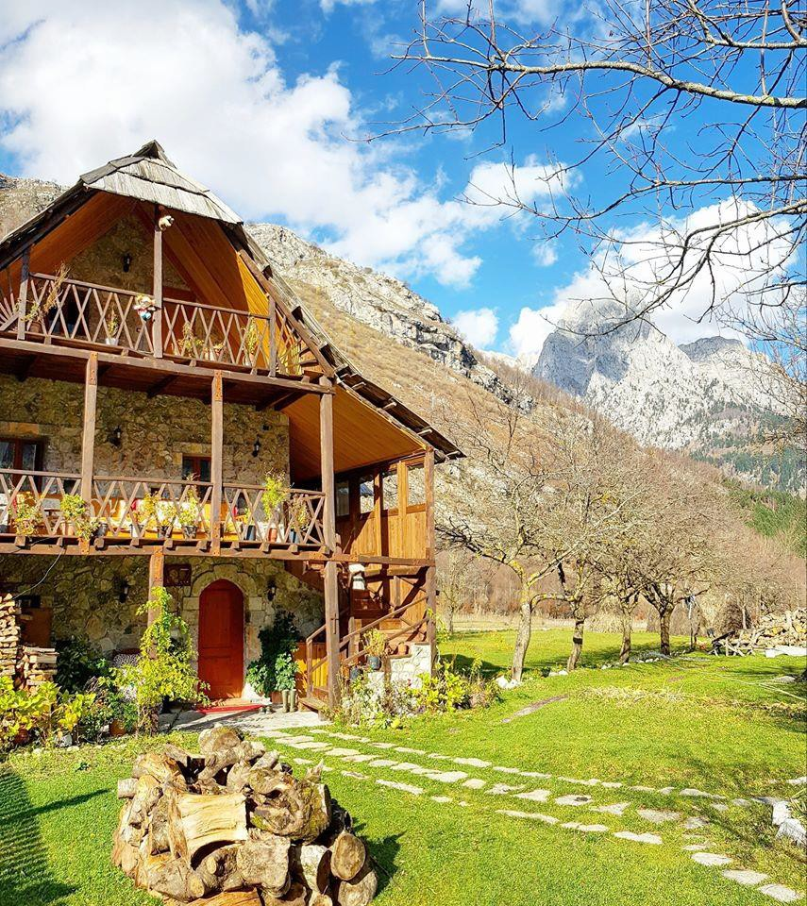
More about Kol Gjoni Guest House

- In Valbona there are few guest houses available that had turned their hand to welcoming visitors and are immensely hospitable.

Check also for Guest House Jezerca & Guest House Arben Selimaj

Guest House Leonardi - Doberdol
This guest house is located in the shepherd village of the Albanian mountains called Doberdol. Accommodations here are in small wooden huts that offer comfort and cleanliness with a great view to the mountains.
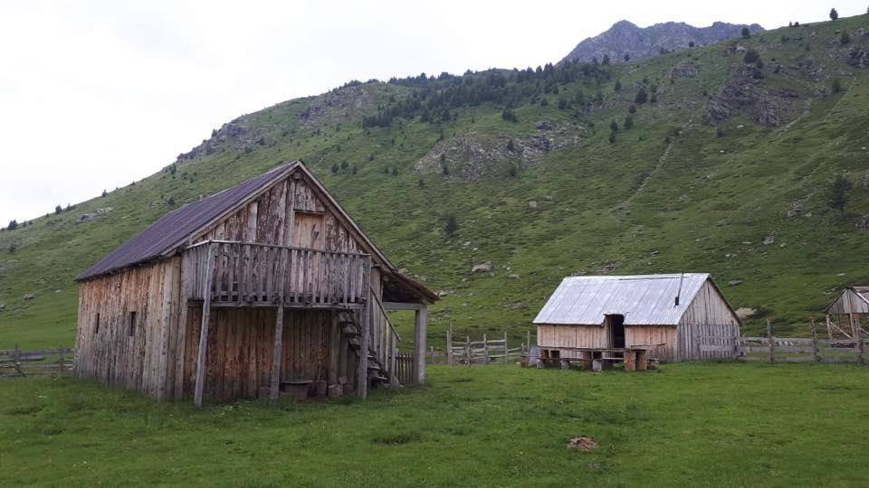
More about Guest House Leonardi

Guest House Lojza - Milisevc
Lojza is a small and very cozy guest house, located in the part of Kosovo mountains. The guest house offers food, beds with clean sheets and always warm water for your shower.
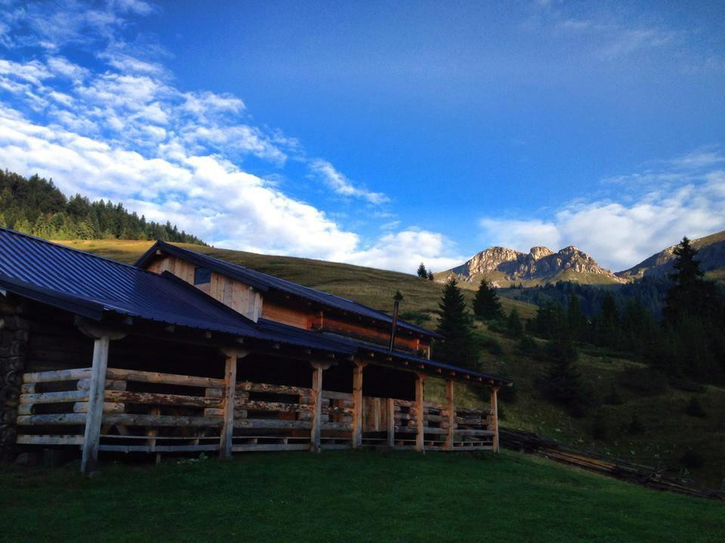
More about Lojza Guest House

Eco Lodge Hrid - Babino Polje
Eco Hrid house belongs to the pioneers of this trail. They offer great conditions in a very clean environment that makes this place very fresh and cozy.
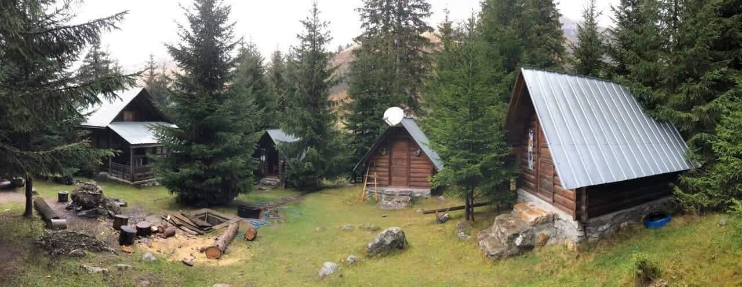
More about Eco Lodge Hrid

Shkodra
Some of the hotels we work with are Promenade Hotel, Rose Garden Hotel & Hotel Carmen. They are situated in the heart of city. The rooms are nice, clean and very comfortable.

Note: depending on their availability, we have mentioned two or more guest houses/hotels for one place.

Link to Hope, Link House, Park Road, Worthing, West Sussex, BN11 2NF
www.linktohope.co.uk

