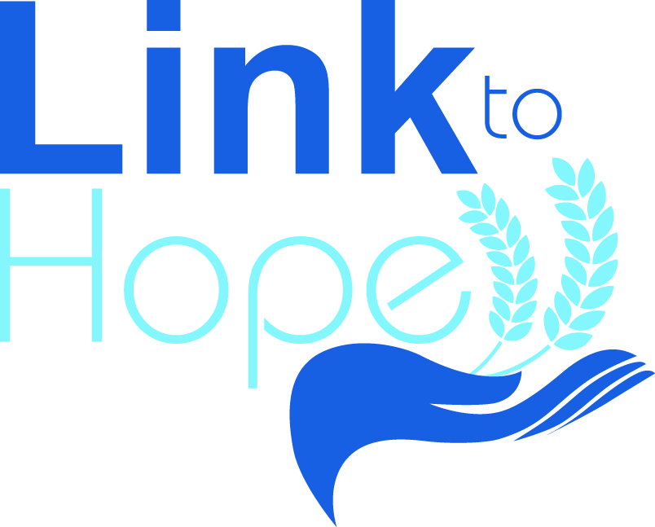
LINK to HOPE
Registered Charity no. 1069722
GIFT AID FORM
For every pound you give, Link to Hope gets an extra 25p from HMRC for FREE!
This means that every £1 you donate will be increased to £1.25 and it won’t cost you another penny.
Completion and return of this form will register you for any current or future donations made.
THANK YOU FOR YOUR SUPPORT
…………………………………………………………………………………………………………………………………………
GIFT AID DECLARATION
TITLE………… FORENAME……………………………………. SURNAME……………………………………………………………
ADDRESS…………………………………………………………………………………………………………………………………………..
…………………………………………………………………………………………………………………………………………………………
…………………………………………………………………………………….. POSTCODE………………………………………………
TELEPHONE NUMBER……………………………………………………………………………………………………………………..
EMAIL ADDRESS……………………………………………………………………………………………………………………………..
AMOUNT…………..£
I want Partnership for Growth T/A Link to Hope to reclaim tax on my donations. This declaration covers all current and future donations until I advise otherwise. I confirm that I am a UK tax payer and understand that if I pay less Income Tax and/or Capital Gains Tax than the amount of Gift Aid claimed on all my donations in that tax year, it is my responsibility to pay any difference. If you pay Income Tax at the higher or additional rate and want to receive the additional tax relief due to you, you must include all your Gift Aid donations on your Self-Assessment tax return or ask HMRC to adjust you tax code.
Please notify the charity if you:
Want to cancel this declaration
Change your name or address
No longer pay sufficient tax on you income and/or capital gains

SIGNATURE……………………………………………………………………………..DATE………………………………………………
Please tick here if you do not wish to hear about the ongoing work of Link to Hope. Your information will not be given to a third party.
Link to Hope, Links House, Park Road, Worthing, West Sussex. BN11 2AN
Tel: 01903 529333 Email: info@linktohope.co.uk www.linktohope.co.uk

