Animal Glove Puppets
For more advanced knitters
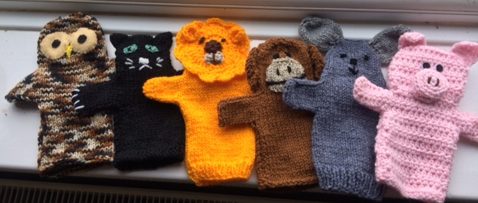
Basic Pattern for body and Head Using DK and size 4mm needles
Cast on 40sts
Rib 6 rows
Change to st st and work 20 rows
*Next row cast on 10 sts k30 turn.
Next row cast on 10 sts P 40 sts Leave remaining sts on a stitch holder.
St-st 8 rows
Cast off 11 sts at beginning of next two rows, leave these 18sts on a stitch holder **
Rejoin yarn to second set of stitches and complete from * to ** but on last row purl across stitches on spare needle 36 stitches.
Continue in st-st for a further 14 rows
Next row SL1 K1 psso K14 k2togSL1 K1 psso K14 K2tog
Next row Purl
Next row SL1K1 psso K12 k2togSL1 K1 psso K12 K2tog
Next row Purl
Next row SL1K1 psso K10 k2togSL1 K1 psso K10 K2tog
Next row Purl
Cast off
Sew up head, arms and body seams

Piglet
Work in pink
Nose cast on 5sts 1st row inc once in each st=10sts
Start with purl row st-st 5 rows Next row (K2tog) to end 5sts. Break off yarn and thread through the 5sts , then gather up all around the other edges. Pull up gathers and stuff with a little stuffing. Fasten off. Sew two black vertical slits for nostrils then sew to face.
Ears Begin at lower edge by casting on 10sts.
1st row inc in each st 20sts. Start with a purl row and st-st 3 rows.
Next two rows K2tog at beginning of row
Then K2tog at each end of next 6 rows (6sts)
K2tog 3 times
Thread yearn through 3 sts then sew around edge.sew cast on edge to side of head.

Rabbit
Ears make two Begin at lower edge cast on 10sts
1st row inc knit wise into every st=20sts
Beginning with a purl row ,st-st 14 rows.
Next row ( K2tog) to end 10sts. Break of wool and gather up. Join row ends of each ear and turn right side out. With this seam at one side of ear, over sew across cast on sts. Sew cast on edges of ears to top of head with ear seams facing towards each other.
Tail in white cast on 7sts(lower edge) . 1st row inc knit wise in every st. 14sts
Beginning with a purl row st-st 4 rows. Continue in st-st and decrease 1st at beginning of next 6 rows- 8sts
Next row (P2tog) to end 4sts
Break off yarn and thread through 4 sts, then gather all round the other edges of knitted piece. Pull up gathers and stuff tail noting that P side of st-st is the right side. Fasten off. Sew to back of body at lower edge.

Lion
Make basic body.
Crochet circular face and sew in place.
Make 4 chains join with slip st. 12 dc into circle. Join with slip st.
2 chains, 1 treble in next st, 2 trebles in each dc join with slip st
Repeat above row
1chain , 1dc in each st join with slip st
1chain( miss 1 dc 5 trebles in next dc, miss one dc 1 slip st.) repeat all around circle.
Ears. Make two. 3chains join to make circle. 10 trebles fasten off
Nose in brown 3chain circle, 12 trebles into circle slip st join. Stuff and sew in place.

Other animals
Use pictures for inspiration.

