COMB CASE INSTRUCTIONS

Here’s how to make a simple case to pop a comb into. You can sew this by hand or on a machine.
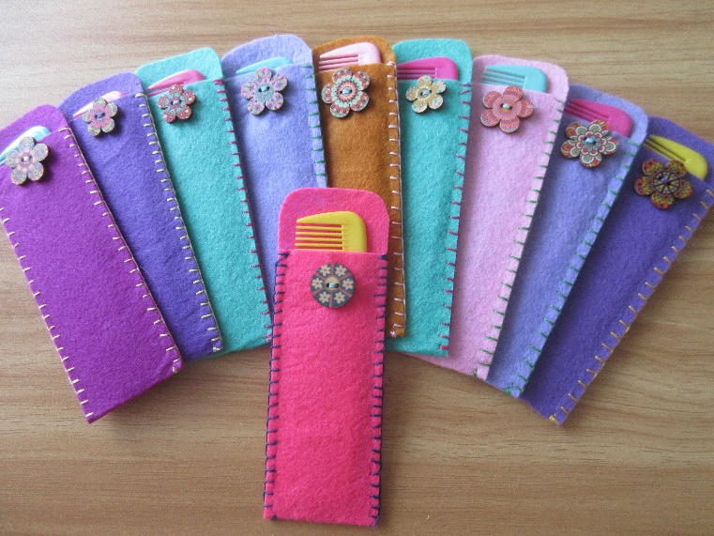
Materials
A4 sheet of craft felt (other stiff fabric could be used)
Sewing thread
Decorative button (optional)
Embroidery thread (optional for hand sewing)

Tools
Scissors
Rotary cutter (optional)
Pencil
Ruler
Sewing needles or sewing machine

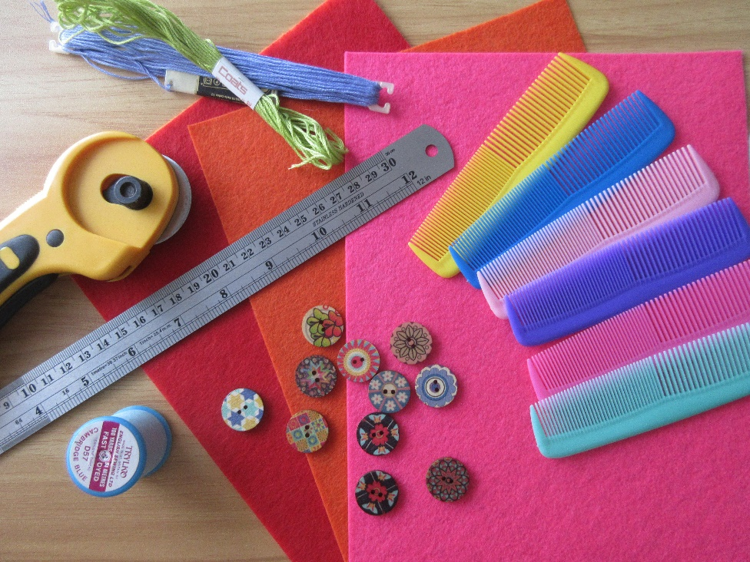

Method

You can usually make four comb cases out of an A4 sheet of craft felt, but it’s always good to check to make sure they will fit before you start cutting the felt.
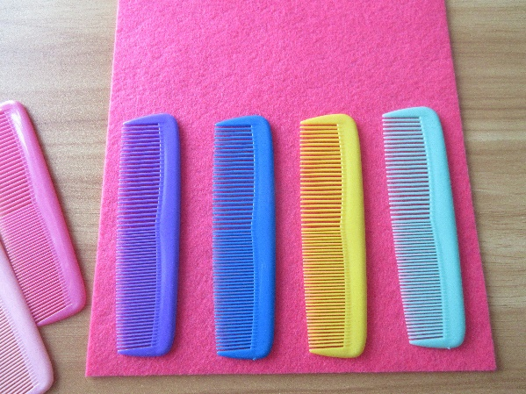

Use a pencil to lightly mark the cutting lines. I fold the sheet in half first, to find the centre line, and then fold each half in half again, to get the sheet divided equally into 4 sections.

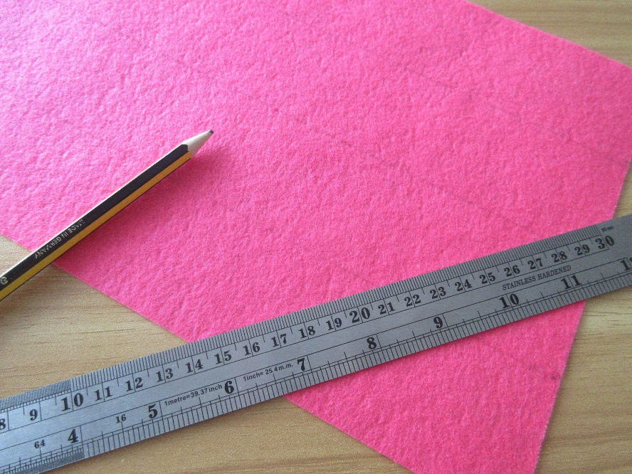

Cut the four long lengths of felt, using either scissors or a rotary cutter – whichever you prefer.

You will now have four pieces of felt to make cases for four combs.

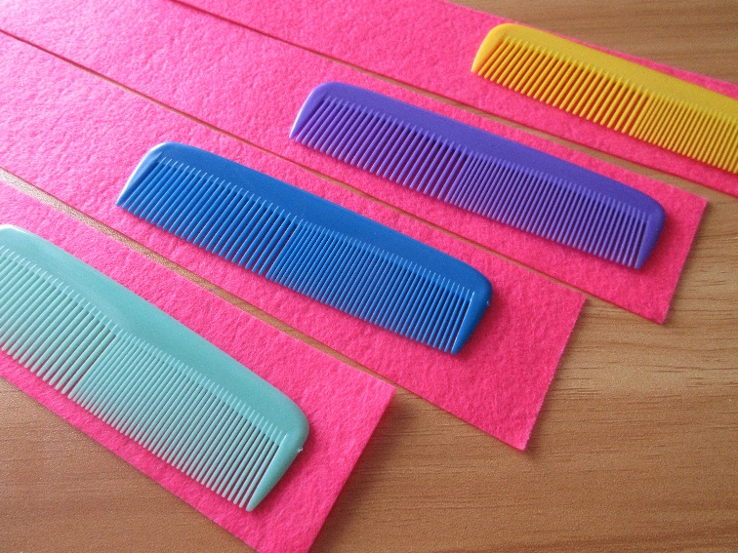

Fold the felt over, so that most of the comb is covered, with just the top peeking out.

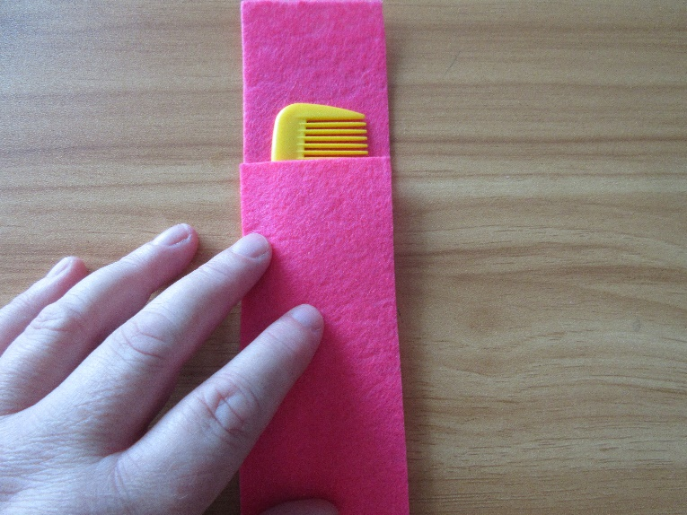

If there is a lot of felt left at the top, cut off the excess.
Or, if you want to, make a fold over top, using a button/buttonhole, Velcro etc.

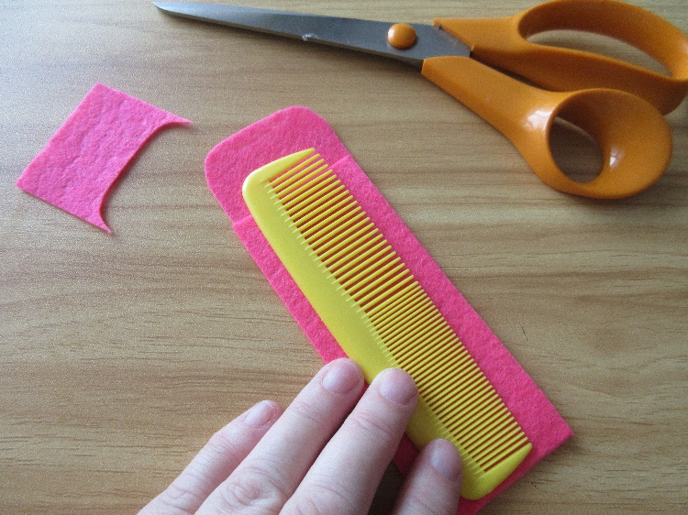
If you want to add a decorative button, or bow, this is a good time to sew it on.

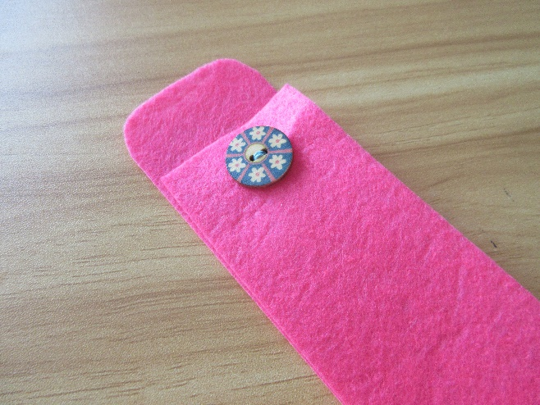

Now you’re ready to sew up the side seams.
You can machine sew the seams, or hand sew them.

For hand sewing I like to use embroidery thread (six strand), in a contrasting colour.
I cut a length of thread, and split it into two lots of three strands.

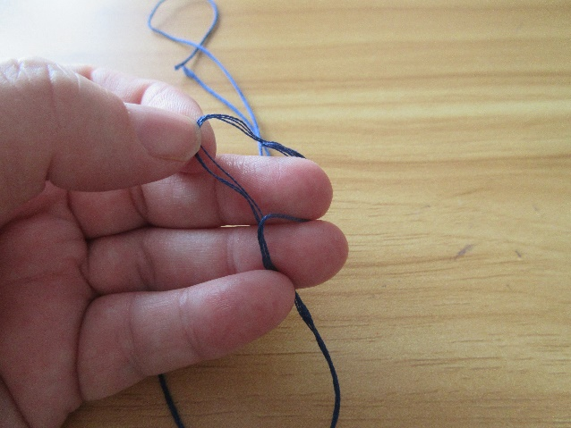

Whichever method of sewing you use, make sure the ends are well secured so that the case will last well.

Blanket stitch looks very decorative when hand sewing.
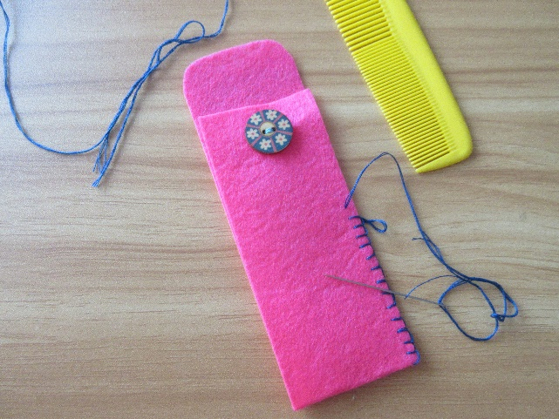
Some examples of hand sewn cases, using different stitches, and with and without decoration.

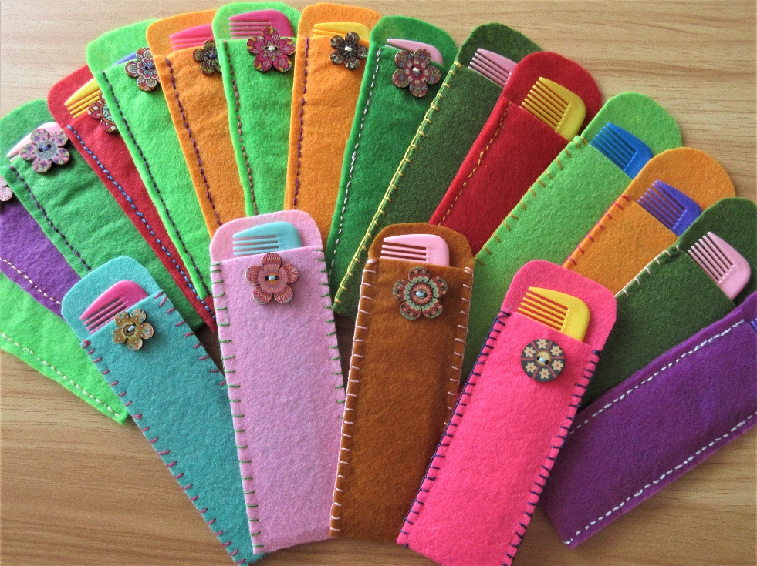

I personally like to put a bundle of three or four combs in a family box, tied together with a length of ribbon (which can be used for in a child’s hair etc.), and one or two combs in an elderly box.

