MINIMAL SEWING NEEDLE CASE

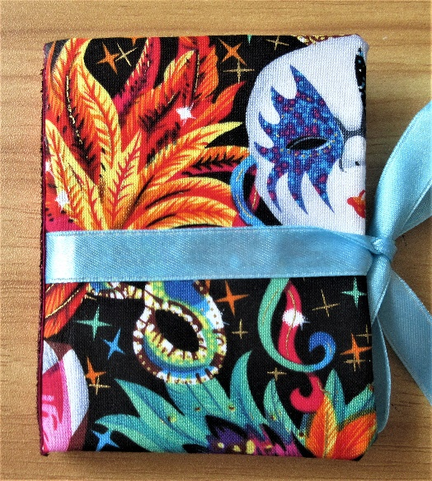

Materials

Firm card (mountboard, or card from a board backed envelope)
Fabric – cotton, polycotton, or anything that doesn’t fray, isn’t too thick, and is suitable for plenty of handling
Sewing thread
Lengths of ribbon
Pieces of felt
Glue (UHU or similar)

Equipment
Scissors
Sewing machine, or sewing needle for hand sewing
2 clothes pegs

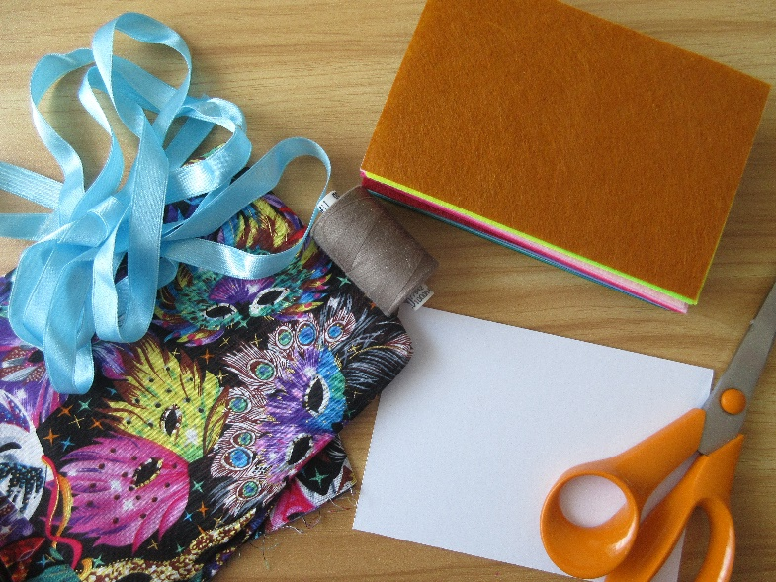

Instructions

You need two pieces of firm card, of the same size.
I use a piece of mountboard, 15 x 11 cms (6” x 4”) approx. which I cut into two pieces. Card from board backed envelopes is fine, although you might want to glue two pieces together for making them extra firm.

The size can be varied, you just need to alter the size of the felt sheets etc if you change the size of the cover.

Lay your pieces of card on your fabric, and cut out the cover, allowing approx. 2cms / 1” of fabric around the edges. You also need to leave a gap between the two pieces of card of approx. ½” / 1.5cms. This is the channel for sewing in the sheets of felt that hold the pins and needles. If you are going to be using a sewing machine, you need to make sure the channel is wide enough for the foot of your machine to go through.

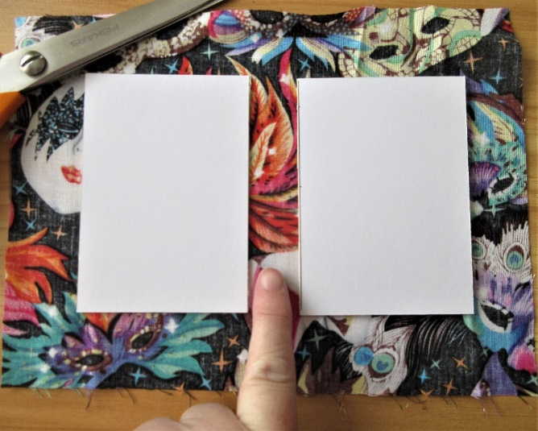

Glue the corners of the fabric onto the card. Put the glue on the fabric, and then bend it over to stick to the card.

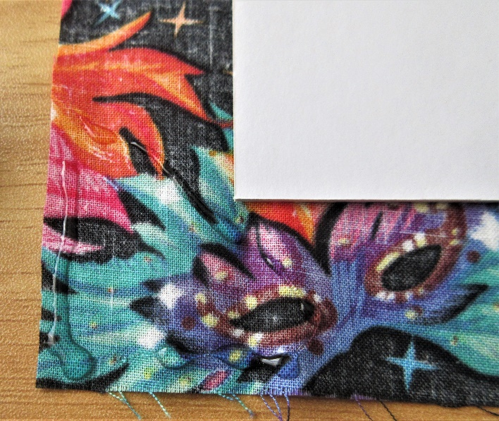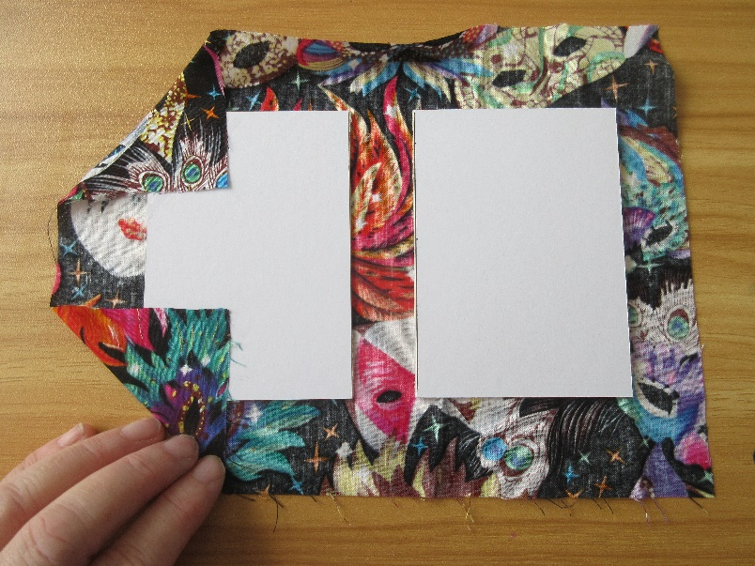

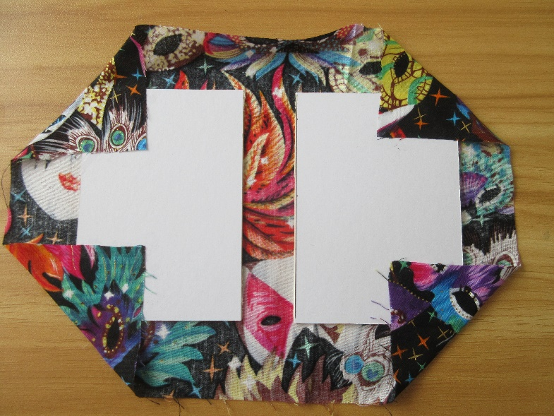

Glue the remaining edges of the fabric to the card (again put the glue on the fabric rather than the card, so that no edges of the fabric are left without glue).

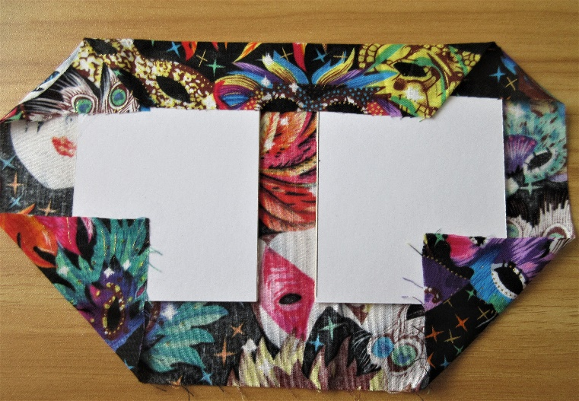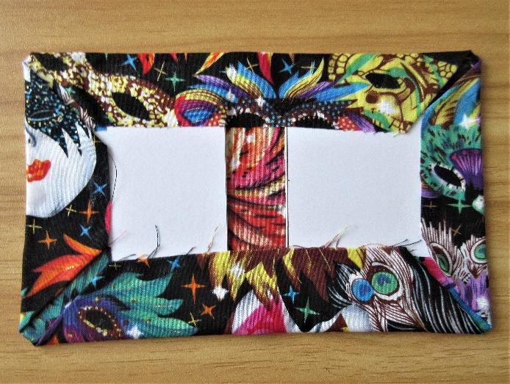
Now you’re ready to attach the felt inside cover. You can cut one A4 sheet of felt into quarters, to give four A6 pieces. If using a different sized cover, remember to adjust the size of your felt for the inside cover.

I like to use a dark colour felt for the inside cover, so that the fabric edges underneath don’t show through.

It’s easiest to put glue around the edges of the piece of felt, and also down the two inside edges of the card, so that all edges are well stuck.

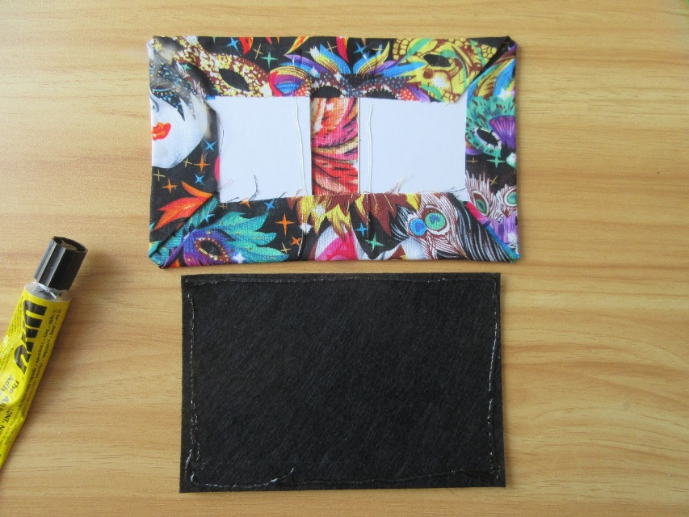

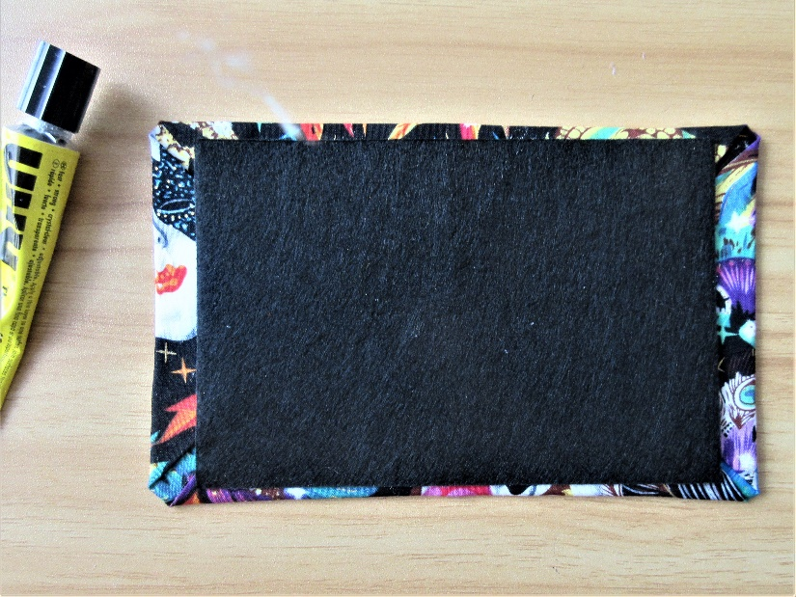

Take two more A6 pieces of felt, either the same or contrasting colours. These will be for sticking the pins and needles into.
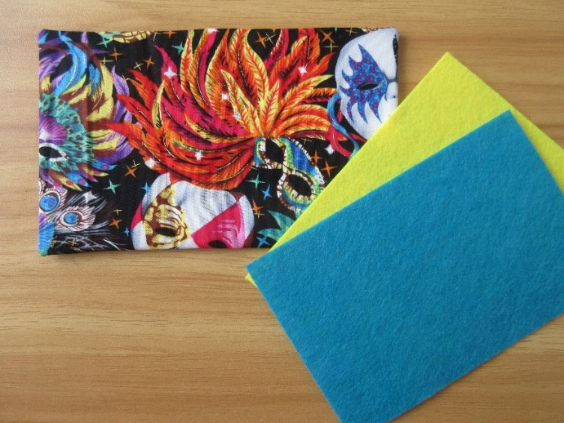
If hand sewing, I find it easiest to fold the needle case in half, to get a crease in the felt, so that there is a guide for sewing a straight line up the centre. You could also mark the line with tailor’s chalk if preferred.

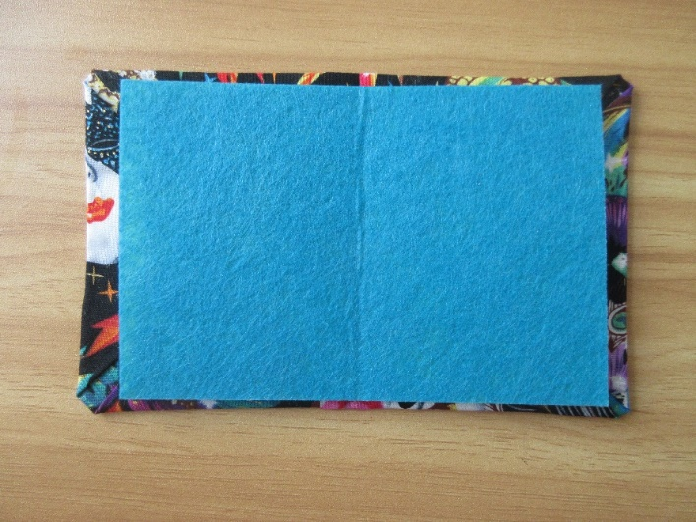

Either machine sew the felt to the cover, or sew it by hand. If sewing by hand, I recommend doubling the sewing thread, and sewing along the centre in one direction, and then going back in the other direction for extra strength.

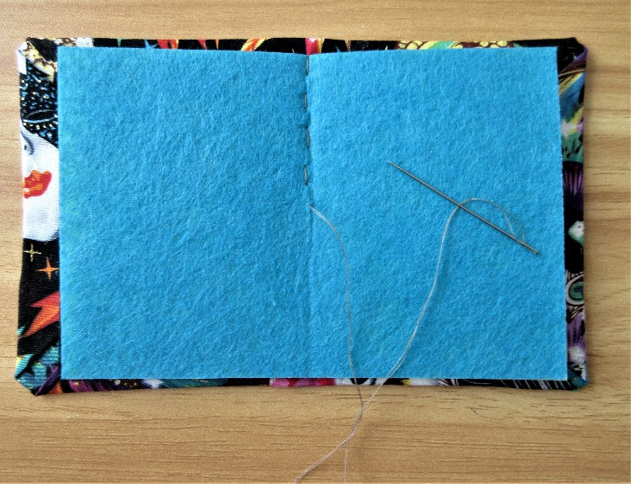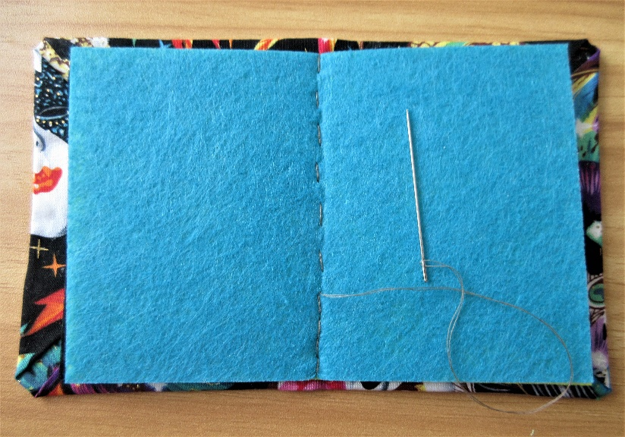

Don’t worry if the back of the seam looks a little wonky! You can cover that later.

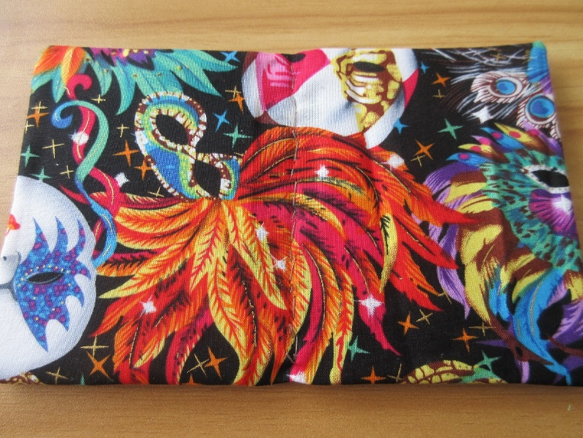

I use ribbon to make ties for keeping the needle case closed, partly because I have lots of lengths of ribbon lying around that need using up, and partly because I can never get Velcro or poppers to line up properly!

Take a piece of ribbon that is 3 x the width of the needle case. Cut the ends on a diagonal to save fraying (you can heat seal them if preferred).

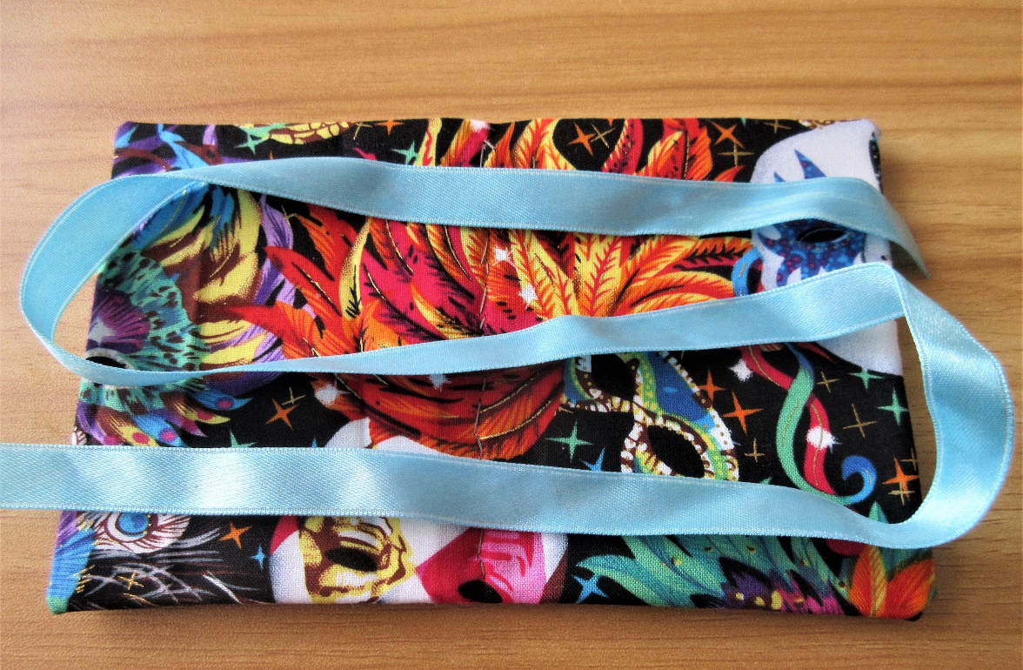

Glue the ribbon across the width of the needle case, making sure that you have an even length either side.

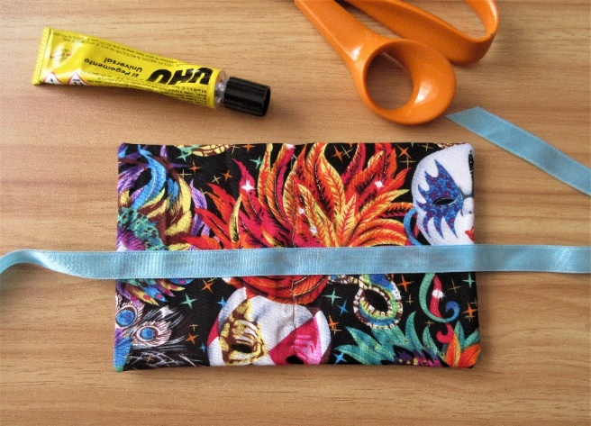

If you want to cover the spine, use another length of ribbon or other trimming, and glue it along the spine of the case. For anything that might fray, allow a small amount either end, that can be glued inside. This step adds an extra bit of prettiness, and uses up shorter lengths of ribbon or braid.

This is where it’s handy to have a couple of clothes pegs to hold the trim in place whilst the glue dries.

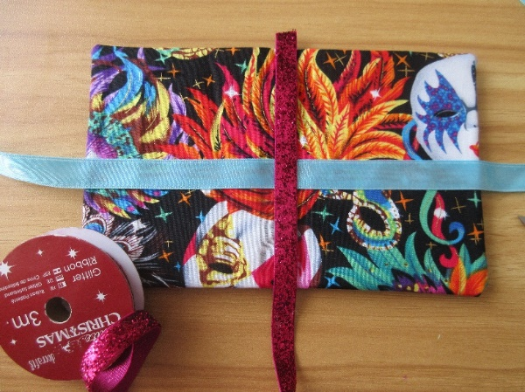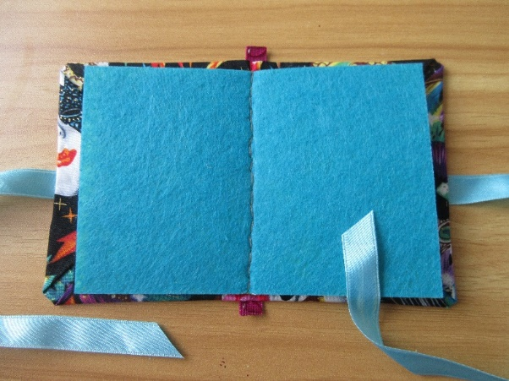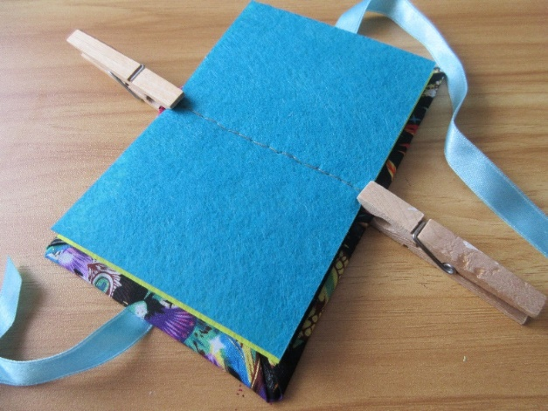

When the glue is fully dried, you can add some pins and needles, tie up the ribbon, and the case is complete.
